**CS 341 – Lab 8**

**Seven Segment Display**

In this lab, you will learn how to use a 7 segment display. We will write to it to display numbers using a decoder chip that simplifies our code. When done, your display should loop through digits 0-9. The starter code can be found [here](https://github.com/whittyh/CS341/tree/main/lab%208) under Lab 8.

Background Information

Seven Segment Displays are used in many consumer devices like calculators, clocks, watches, counters and microwave ovens. They are made out of LEDs and are low cost devices to display information. They come in a variety of colors and sizes. Some displays have a single digit and others have multiple digits.

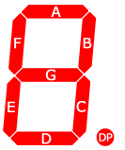

Seven segment displays consist of 7 LEDs, called segments, arranged in the shape of an “8” and a dot on the right side of the digit that serves as a decimal point. Each segment is named with a letter A to G, and DP for the decimal point. For example, to display a number 7, the segments A, B and C must be lit up.

To make the matching of digits to segments easier, seven segment display chips are connected to 4-bit decoders which maps the digits in binary (e.g. 0 – 9 and some special characters) to the correct segments to display that number. Instead of lighting the groups of segments to form a digit, the user programs the 4-bit decoder to light up the digits as follows:

|  |  |  |  |  |
| --- | --- | --- | --- | --- |
| **Decoder Input** | | | |  |
| **bit 3** | **bit 2** | **bit 1** | **bit 0** | **Display character** |
| LOW | LOW | LOW | LOW | 0 |
| LOW | LOW | LOW | HIGH | 1 |
| LOW | LOW | HIGH | LOW | 2 |
| LOW | LOW | HIGH | HIGH | 3 |
| LOW | HIGH | LOW | LOW | 4 |
| LOW | HIGH | LOW | HIGH | 5 |
| LOW | HIGH | HIGH | LOW | 6 |
| LOW | HIGH | HIGH | HIGH | 7 |
| HIGH | LOW | LOW | LOW | 8 |
| HIGH | LOW | LOW | HIGH | 9 |
| HIGH | LOW | HIGH | LOW | Special Character |
| HIGH | LOW | HIGH | HIGH | Special Character |
| HIGH | HIGH | LOW | LOW | Special Character |
| HIGH | HIGH | LOW | HIGH | Special Character |
| HIGH | HIGH | HIGH | LOW | Special Character |
| HIGH | HIGH | HIGH | HIGH | Special Character |

In this lab we will make use of a CD4511BE decoder chip and it is connected to a common cathode seven segment display. We will connect 4 digital pins of the Arduino computer to the decoder chip (pin 4 for bit 0, pin 5 for bit 1, pin 6 for bit 2, and pin 7 for bit 3) as shown in the diagram:

The Circuit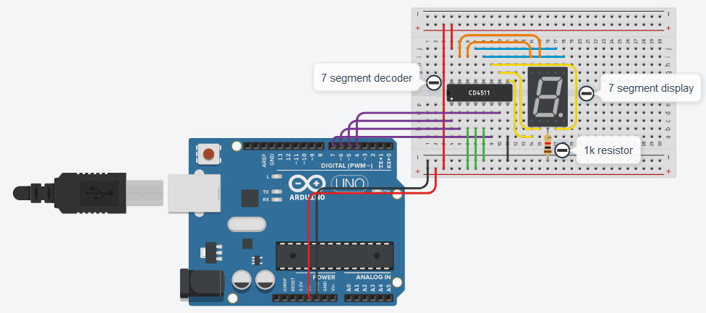

**Closeup**

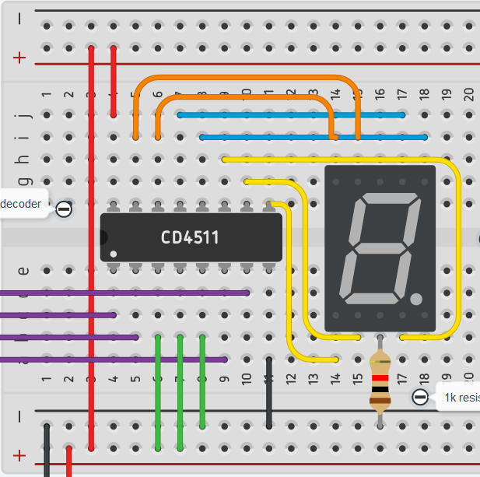

Program the Hardware

Program your 7 segment display so that it counts up from 0. When it gets to 9 it should loop back to 0 again. The CD4511BE decoder only works with common cathode seven segment displays.

Lab Report

Please submit your lab via email to [whitney.hamnett001@umb.edu](mailto:whitney.hamnett001@umb.edu) . For help, see corresponding material on my github: www.github.com/whittyh/cs341